Proposals dated 08 September 2026, J.
Proposals for Improving the Regional Mechanism for International Response to Large-Scale Emergencies
The populations and territories of the Central Asian states, as in the rest of the world, face serious challenges from growing exposure and vulnerability to natural, man-made, environmental and climate risks, resulting from the increasing scale of human impact on the environment, ecosystem degradation, and the emergence of new challenges and risk factors that hinder sustainable development.
A significant part of the territory of Central Asia, and most of its major cities and settlements, lie in a zone of high seismic risk and face serious challenges in reducing vulnerability to devastating earthquakes and other natural and man-made risks.
Over the past 100 years, every country in the region has experienced devastating earthquakes, including the 1911 Almaty and Sarez earthquakes, the 1946 Chatkal earthquake, the 1948 Ashgabat earthquake, the 1949 Khait earthquake, the 1966 Tashkent earthquake, and others — which claimed the lives of hundreds of thousands of people and caused massive destruction and damage amounting to billions of dollars.
Devastating earthquakes and other catastrophic disasters that have occurred in recent decades have shown that no country in the world can be absolutely certain that it will not need assistance from other states, or international assistance from development partners and humanitarian organizations.
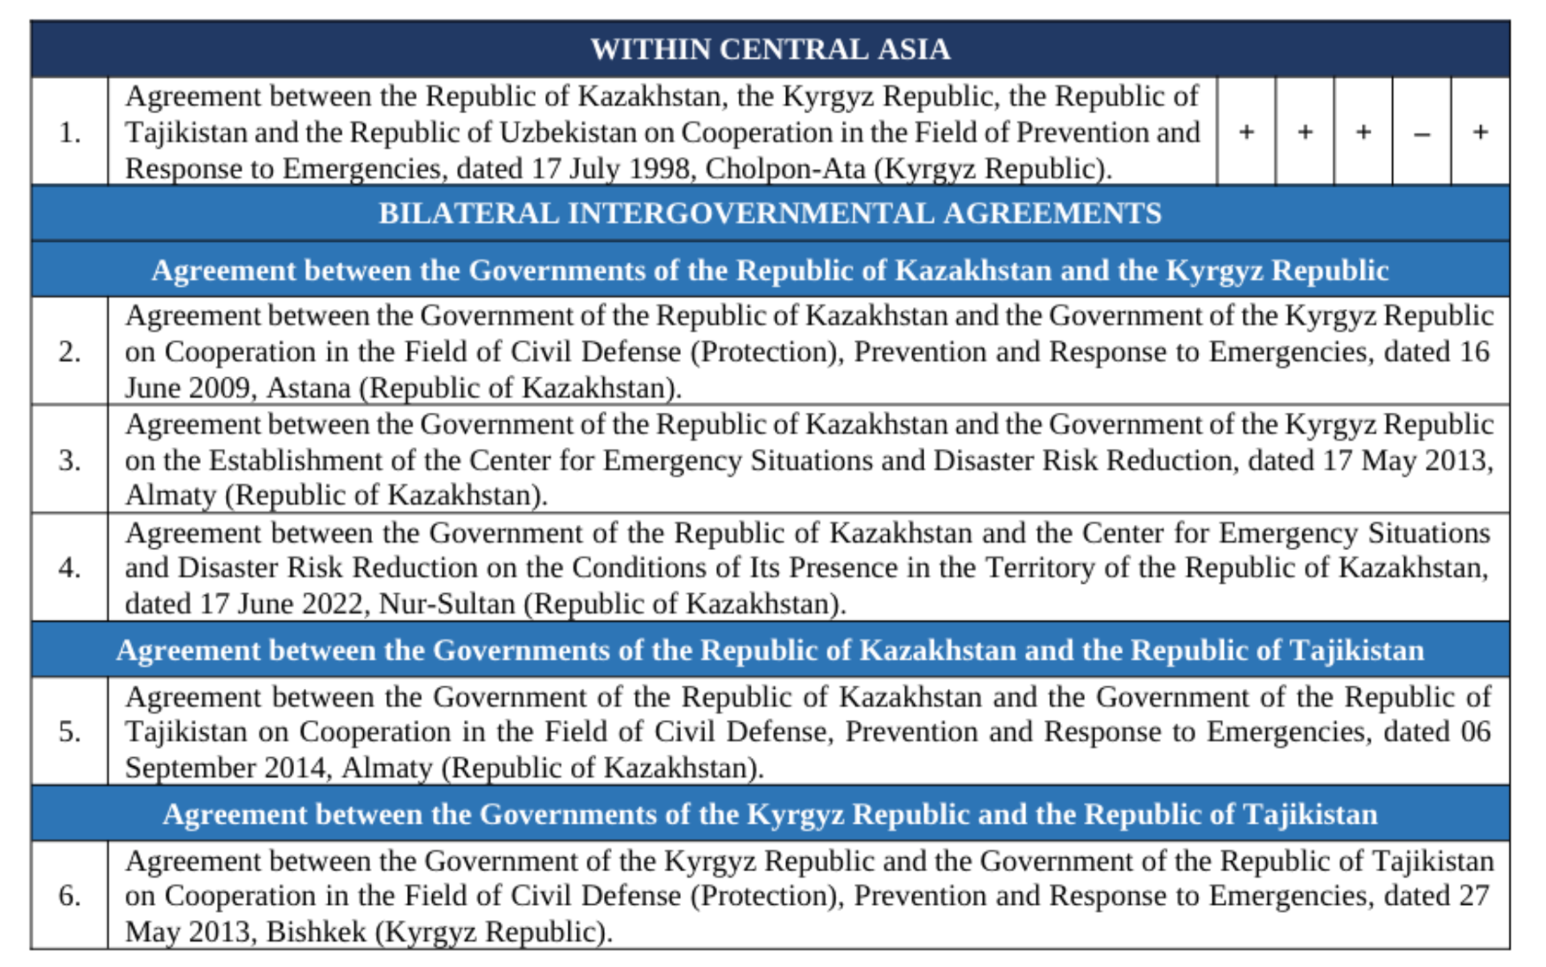
Given the importance of joining efforts and taking coordinated joint action, the Central Asian states have established and developed cooperation in the field of disaster prevention and response, based on intergovernmental agreements ratified between the Governments of the Central Asian countries; these agreements relate only to cooperation in the prevention and response to emergencies.

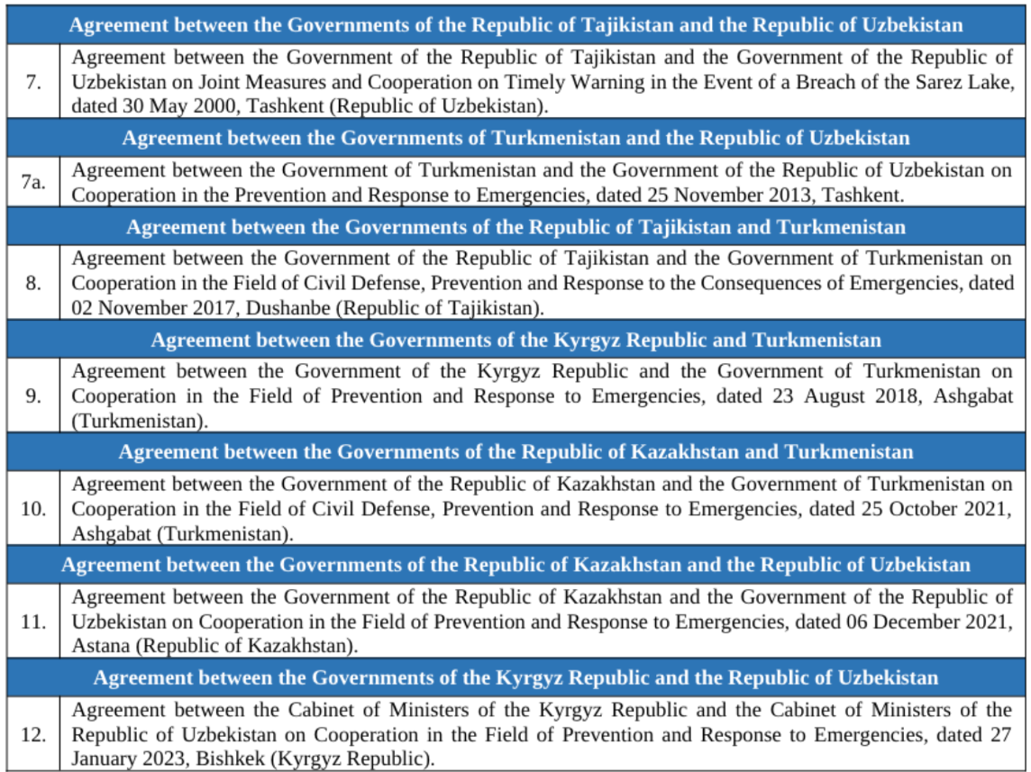

Note: in the source document, the five “+/–” columns next to item 1 indicate the participating states' status under the 1998 multilateral agreement; the column headings (country names) were not visible in the original scanned table.
At the same time, the above-mentioned intergovernmental agreements in force, ratified between the Governments of the Central Asian countries, relate only to cooperation in the prevention and response to emergencies.
Thus, it can be clearly stated — and this is confirmed in practice — that when emergencies occur, cooperation in emergency response, based on the terms and definitions applied, covers only the short-term period (from the first hours up to several weeks, or at most a month) of emergency rescue and other urgent operations aimed at saving lives and preserving people's health, reducing damage to the natural environment and material losses, as well as containing the emergency zones and stopping the hazardous factors characteristic of them.
At the same time, in the event of large-scale emergencies (for example, devastating earthquakes) with catastrophic consequences, the affected state or states will need not only assistance in emergency response, but also assistance in eliminating the consequences of such emergencies — both from other states and in the form of long-term assistance from the international community: international organizations working in the field of international and humanitarian response to emergencies at the regional and global levels.
It is well known that in large-scale emergencies, where the catastrophic destruction of housing and infrastructure and the number of victims are counted in the tens and hundreds of thousands, and the damage amounts to tens and hundreds of billions of dollars, virtually no affected state can cope with eliminating the consequences, restoring engineering infrastructure, housing and the environment, and providing social rehabilitation assistance to the population (a process lasting from several months to several years) using its own forces and resources alone, without external assistance from the international community.
In this context, the Center for Emergency Situations and Disaster Risk Reduction is invited to develop, by 20 April 2027, and submit for consideration at the next Regional Forum — Meeting of the Heads of Emergency Agencies of the Central Asian States: the “Concept for Establishing a Regional Mechanism for International Response to Large-Scale and Cross-Border Emergencies.”
Earlier, the proposal to establish a regional mechanism for international response to large-scale and cross-border emergencies was preliminarily considered, agreed upon, and reflected in the “Joint Statement of the Heads of Emergency Agencies of the Central Asian States on Strengthening Earthquake Resilience, Enhancing Response Preparedness and Ensuring Recovery, within the Framework of the International Day of Remembrance for Victims of Earthquakes,” dated 29 April 2026, Tashkent, Republic of Uzbekistan, in which the heads of the emergency agencies of the Central Asian states (hereinafter — the Parties) stated the following:
- The Parties intend to implement practical measures to strengthen the regional coordination mechanism for responding to large-scale and cross-border emergencies, and to raise awareness of earthquakes, response preparedness and recovery;
- The Parties expressed their readiness to hold consultations on the draft Regional Agreement on International Disaster Response, which would form the legal basis for strengthening the capacity of the Center for Emergency Situations and Disaster Risk Reduction (CESDRR), operating since 2016, by giving it additional tasks and functions relating to the coordination of international and humanitarian response in the event of devastating earthquakes and other large-scale and cross-border emergencies.
The objectives of establishing the “Regional Mechanism for International Response to Large-Scale and Cross-Border Emergencies” (hereinafter — RMIR) are:
- Strengthening comprehensive, mutually beneficial cooperation among the Central Asian states on ensuring preparedness for international response to large-scale emergencies and carrying out recovery operations, based on the principles of friendship, good-neighborliness, inter-ethnic harmony, trust and mutual understanding;
- Establishing an effective mechanism for response and coordination of joint actions to eliminate the consequences of large-scale emergencies and carry out recovery operations, and to provide international assistance in compliance with national legislation, intergovernmental agreements, universally recognized norms and principles of international law, UN strategic policy documents, and the rules, principles and procedures for providing international and humanitarian assistance.
The main tasks of RMIR are:
- coordinating and carrying out joint activities of the emergency agencies of the Central Asian states with international and non-governmental organizations and other stakeholders working at the regional and global level in the field of international response and humanitarian assistance in large-scale emergencies;
- the practical implementation of existing bilateral and multilateral intergovernmental agreements in the field of disaster prevention and response involving the Central Asian countries, as well as international strategic policy documents of the UN and other international organizations, insofar as they relate to ensuring preparedness for international response to large-scale emergencies and carrying out recovery operations, based on universally recognized norms and principles of international law;
- organizing the operation of a regional coordination mechanism that ensures consistency of action among the participating states, international organizations and other partners in providing international assistance;
- ensuring the timely exchange of information on emergencies, forecasts of their development, the scale of consequences, requests, the needs of the affected state, and available response capabilities;
- creating an information environment that allows for obtaining, within the shortest possible time, the data and information necessary regarding the threat or occurrence of large-scale emergencies, as well as on the progress of efforts to eliminate their consequences;
- coordinating a joint assessment of the situation and the needs of the affected state in order to determine priority areas for international response and humanitarian assistance;
- assisting in the mobilization, coordination and effective use of international assistance and of search-and-rescue, medical, engineering, logistical and other specialized resources provided by the participating states and international partners;
- coordinating joint actions to eliminate the consequences of large-scale emergencies and carry out recovery operations, and to provide international assistance in compliance with national legislation, intergovernmental agreements, UN strategic policy documents, and the rules, principles and procedures for providing international and humanitarian assistance;
- facilitating the simplification and harmonization of procedures for crossing state borders, customs clearance, and the import of humanitarian aid, equipment and machinery, and the admission of personnel sent to eliminate the consequences of emergencies;
- organizing joint planning, preparation and conduct of exercises and training, and the exchange of experience aimed at improving the readiness of the participating states for joint international response;
- developing and introducing unified regional procedures, standards, methodologies, guidelines and other documents based on universally recognized norms and principles of international law;
- promoting the development and strengthening of the joint capacity of the participating states through the exchange of expert knowledge, modern technologies, innovative solutions and best response practices;
- creating a regional register of the forces and resources of the States Parties for the purpose of emergency response to large-scale emergencies;
- carrying out other tasks in the field of preventing and responding to large-scale emergencies, as determined by the competent authorities of the Parties.
The competent authorities responsible for implementing this Agreement are the emergency agencies of the Central Asian states — the authorized state bodies in the field of civil protection/defense and the prevention and response to emergencies.
It is proposed to establish the following bodies within RMIR:
- The Council of Heads of Emergency Agencies of the Central Asian States (hereinafter — the Council) — the governing body of RMIR, composed of the heads (first executives) of the state bodies authorized in the field of civil protection/defense and the prevention and response to emergencies of the states parties to this Agreement;
- A permanent intergovernmental coordinating body, to assist in organizing, conducting and coordinating agreed joint measures in the field of preventing and responding to large-scale and cross-border emergencies, international response and the provision of humanitarian assistance, to be established on the basis of the existing Center for Emergency Situations and Disaster Risk Reduction (hereinafter — the Center), through the accession of other states to the Agreement between the Government of the Republic of Kazakhstan and the Government of the Kyrgyz Republic on the Establishment of the Center for Emergency Situations and Disaster Risk Reduction, dated 17 May 2013, Almaty.
The main modes of operation of RMIR are:
- Day-to-day operating mode. In the absence of large-scale emergencies, the Parties, the Council and the Center carry out their activities in the day-to-day operating mode;
- International response mode for large-scale emergencies. When a large-scale emergency occurs that cannot be eliminated by the forces and resources of a single country, the Parties, the Council and the Center switch to operating in the international response mode for large-scale emergencies and the elimination of their consequences, in accordance with the functions and powers assigned to them.
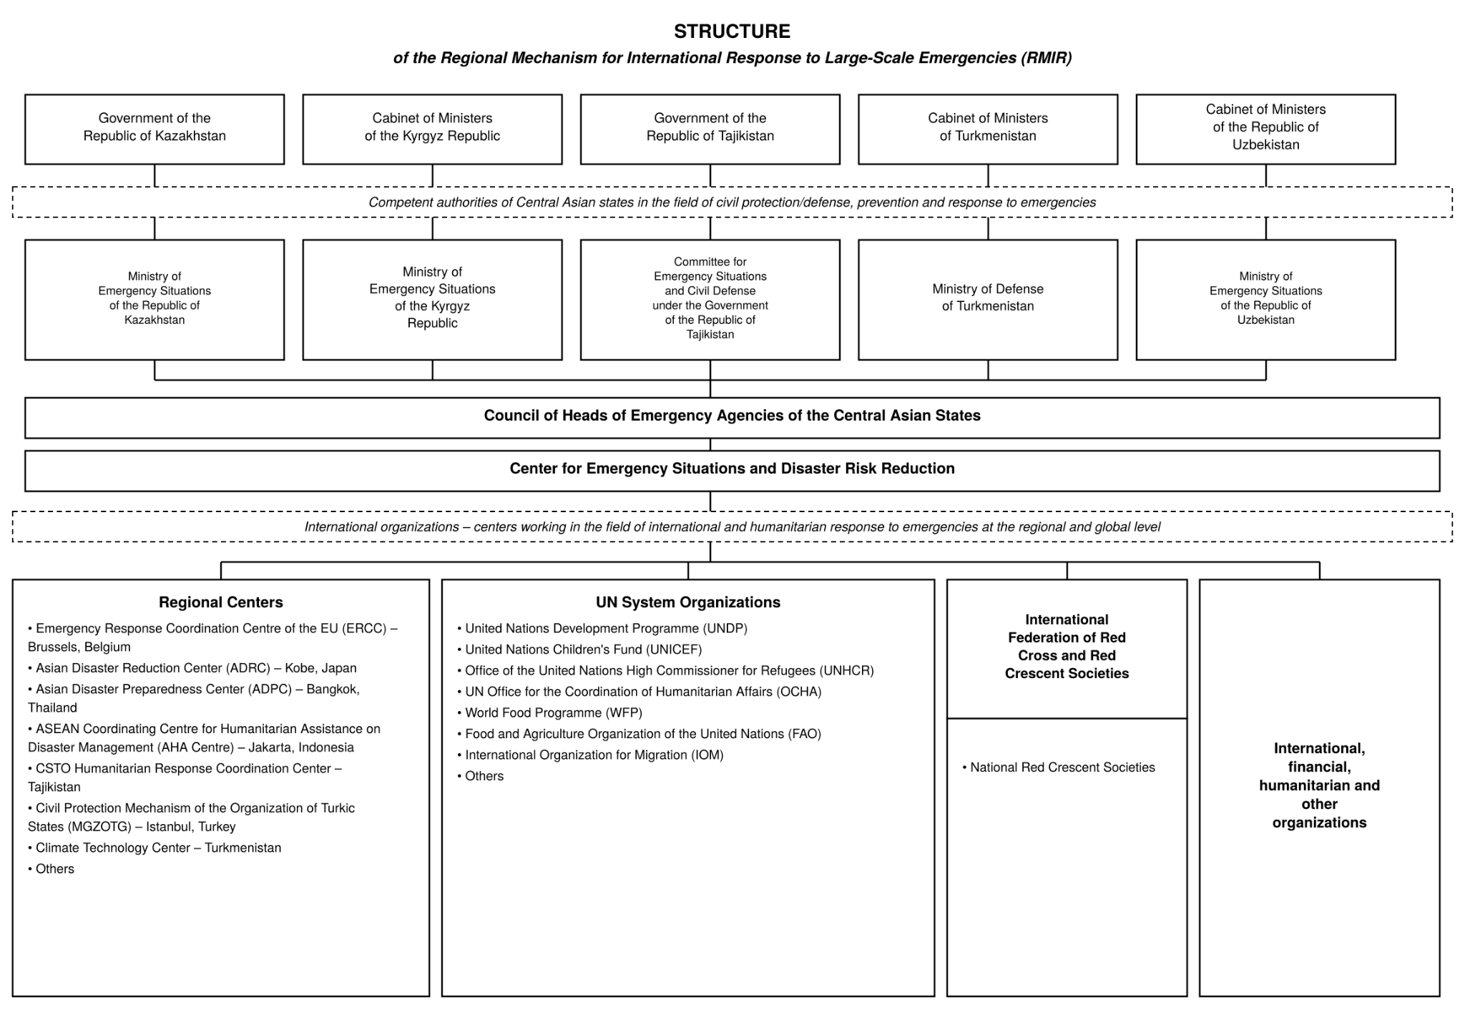
Proposed structure of RMIR:
Concepts — Definitions:
“Emergency response”:
- carrying out emergency rescue and other urgent operations;
- the containment and cessation of the factors that caused the emergency; emergency rescue and other urgent operations carried out when emergencies occur, aimed at saving lives and preserving people's health, and reducing the extent of damage;
- emergency rescue and other urgent operations carried out when an emergency occurs, aimed at saving lives and preserving people's health, reducing the extent of damage to the natural environment and material losses, as well as containing emergency zones and stopping the hazardous factors characteristic of them;
- emergency rescue and other urgent operations carried out when an emergency occurs, aimed at saving people's lives, containing the emergency and its characteristic hazardous factors, and reducing damage to the natural environment and material losses; potentially hazardous facilities are industrial enterprises, storage facilities and other sites where an accident would threaten the lives and activities of personnel as well as of the population living near such facilities;
- a set of rescue and urgent operations carried out when an emergency occurs, aimed at saving lives and preserving people's health, reducing the extent of harm to the natural environment and material losses, as well as containing emergency zones and stopping hazardous factors.
“Elimination of the consequences of emergencies” — measures carried out to restore engineering infrastructure, housing and the environment, to provide social rehabilitation assistance to the population, and to compensate for harm (damage) caused to individuals and legal entities as a result of large-scale emergencies.
“International response mechanism” — a set of interconnected international legal, institutional and organizational mechanisms that ensure the timely coordination of actions by states and international organizations to prevent, contain and eliminate the consequences of international crises, conflicts, emergencies and other global challenges.
“International response” — a set of measures, systems, principles, procedures and tools by which states, international organizations and other subjects of international law coordinate and carry out joint actions in response to large-scale and cross-border emergencies that cannot be eliminated by the forces and resources of one of the Parties alone.
“Large-scale emergency” — an emergency whose scale and consequences affect a significant territory, is accompanied by a significant number of victims and substantial material damage, and exceeds the national response capabilities of the affected state;
“Humanitarian assistance” — material and financial resources, food, medicines, and consumer goods transferred free of charge by foreign states and humanitarian organizations, not intended to generate commercial gain for either the sender or the recipient, and directed toward improving the living conditions of the population;
“Humanitarian assistance organizations” — foreign, regional, intergovernmental or international non-profit legal entities whose mandated activity is aimed at providing humanitarian assistance.

Background information: How the UN responds to crises
The UN has a mandate to coordinate humanitarian assistance to populations affected by conflicts and natural disasters. The international community relies on the UN to coordinate humanitarian assistance in emergencies caused by natural and man-made disasters, particularly in situations that exceed the response capacity of national authorities.
Inter-Agency Standing Committee (IASC)
Established by the General Assembly pursuant to Resolution 46/182 in 1991, the Inter-Agency Standing Committee (IASC) is the oldest, highest-level forum for coordinating humanitarian action within the UN system. It brings together the heads of 19 UN agencies and other organizations, who jointly develop policy, set priority actions, and mobilize resources for crises.
The Committee is chaired by the Emergency Relief Coordinator. It holds regular meetings to ensure a rapid and effective response and raises important issues for consideration by the Secretary-General and the Security Council. Supported by expert groups, the Committee focuses on a unified approach to providing humanitarian assistance.
Central Emergency Response Fund (CERF)
CERF provides rapid funding for crisis response worldwide, accelerating assistance in natural disasters, conflicts and under-funded emergencies. The Fund can provide assistance within hours of a disaster.
Office for the Coordination of Humanitarian Affairs (OCHA)
The Office for the Coordination of Humanitarian Affairs (OCHA) works to align international humanitarian assistance efforts, ensuring the rapid and effective delivery of aid to people affected by crises. OCHA brings together the efforts of governments, non-governmental organizations and UN agencies to assess needs, mobilize resources and optimize response measures. It also advocates for humanitarian principles and works to improve crisis preparedness and reduce risks worldwide.
OCHA manages the UN Disaster Assessment and Coordination (UNDAC) system, which deploys teams to assist countries affected by natural disasters or sudden-onset emergencies. These teams can be deployed within 12–48 hours and are trained to assess the needs of the population and coordinate the delivery of humanitarian assistance, including food, shelter and medical care. They work with local authorities to ensure an effective and adequate response.
Specialized UN Agencies
Cluster Activity | Lead Agency
Coordination of shelter, land and territory issues | IOM / IFRC
Education | UNICEF
Food security | WFP / FAO
Health | WHO
Logistics and telecommunications | WFP
Nutrition | UNICEF
Protection | UNHCR
Water, sanitation and hygiene (WASH) | UNICEF

